
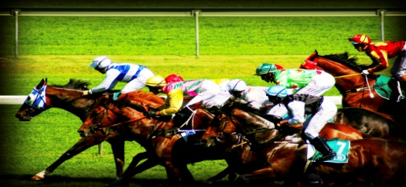

Tues Nov 4th All Riders Saddle up for a Day of punting & Frivolity @ the bowling club rooms.
The Day kicks of from 11am till late & has betting with our very own in house bookies from race 3 onwards. Entry is $15 Adults $5 for kids over 5 or $40 a Family (2Adults +3 kids) & Includes Gourmet Spit Roast with Salad & Seafood Buffet All drinks @bar prices
 **Best Dressed Lady wins a prize (as judged by our panel of experts led by the esteemed Charlie Walker**
Free Champa's For Ladies All Day

